

**MOTOR VEHICLE THEFT ANALYSIS (SQL REPORT)**

***1. What day of the week are vehicles most often and least often stolen?***

SELECT

date_stolen AS day_of_week,

COUNT (*) AS theft_count

FROM stolen_vehicles

GROUP BY

day_of_week

ORDER BY

theft_count DESC;

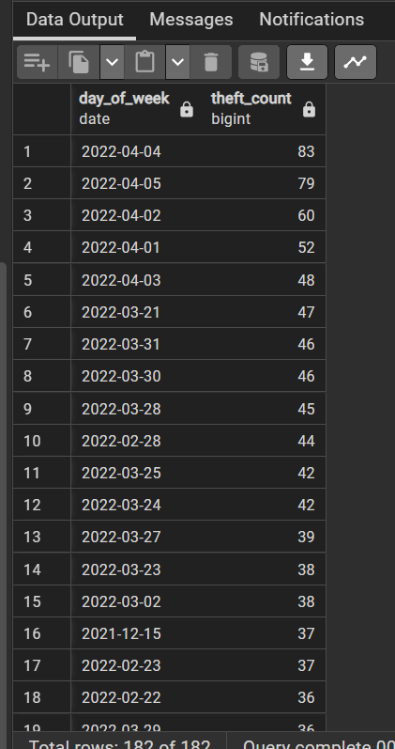

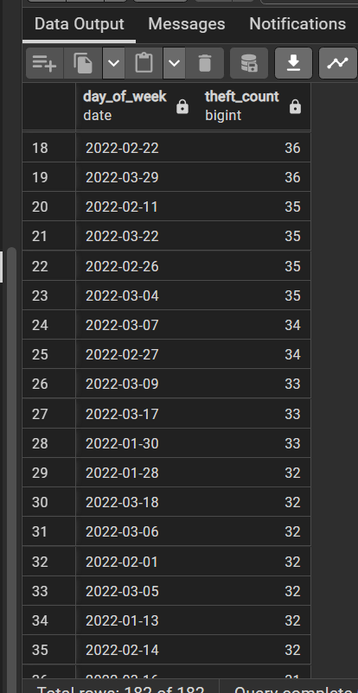

***2. What types of vehicles are most often and least often stolen?***

***--Does this vary by region?***

SELECT vehicle_type,

COUNT (*) AS theft_count

FROM stolen_vehicles

GROUP BY vehicle_type

ORDER BY

theft_count DESC;

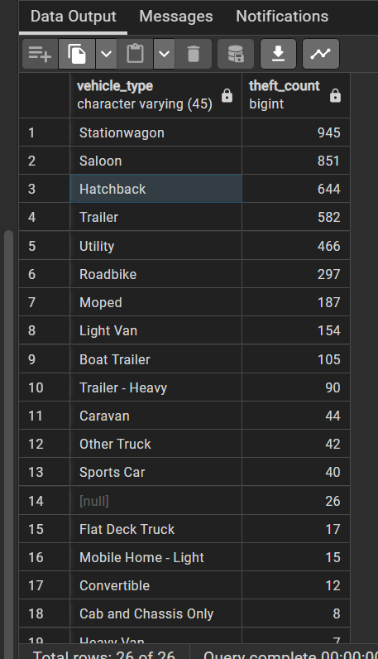

***--USING SUBQUERY (REGION)***

SELECT md.make_type

AS vehicle_type, l.region,

COUNT (*) AS num_thefts

FROM stolen_vehicles sv

JOIN make_details md ON sv.make_id = md.make_id

JOIN locations l ON sv.location_id = l.location_id::TEXT

GROUP BY md.make_type, l.region

ORDER BY l.region, num_thefts DESC;

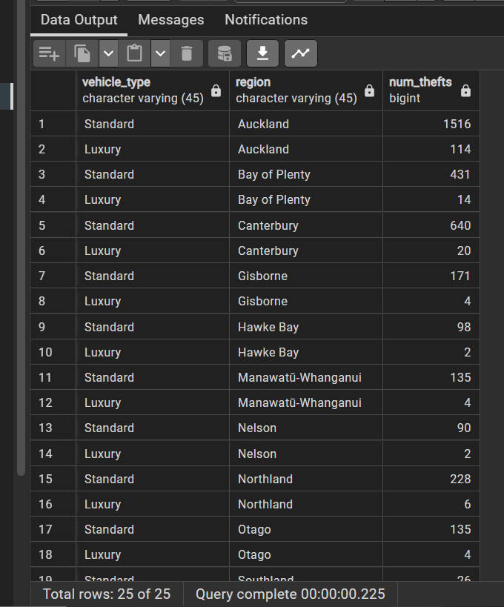

***3. What is the average age of the vehicles that are stolen? Does this vary based on the vehicle type*?**

SELECT

AVG(EXTRACT(YEAR FROM AGE(CURRENT_DATE, DATE_TRUNC('year', TO_DATE(CAST(sv.model_year AS TEXT), 'YYYY'))))::INTEGER) AS avg_age

FROM stolen_vehicles sv;

SELECT md.make_type AS vehicle_type,

AVG(EXTRACT(YEAR FROM AGE(CURRENT_DATE, DATE_TRUNC('year', TO_DATE(CAST(sv.model_year AS TEXT), 'YYYY'))))::INTEGER) AS avg_age

FROM stolen_vehicles sv

JOIN make_details md

ON sv.make_id = md.make_id

GROUP BY md.make_type;

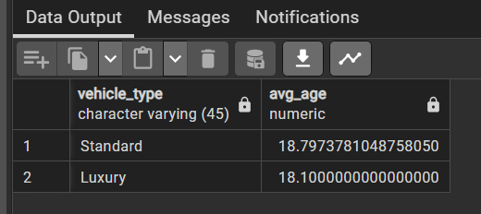

***4. Which regions have the most and least number of stolen vehicles? What are the characteristics of the regions?***

SELECT l.region,

COUNT (*) AS num_thefts,l.population

FROM stolen_vehicles sv

JOIN locations l ON sv.location_id = l.location_id::TEXT

GROUP BY l.region, l.population

ORDER BY num_thefts DESC;

